B”H

Issue:

* Heroku doesn’t provide static IP
* SQL Azure uses a whitelist IP address firewall for access
* Right now its disabled by allowing all IP addresses which is not safe:

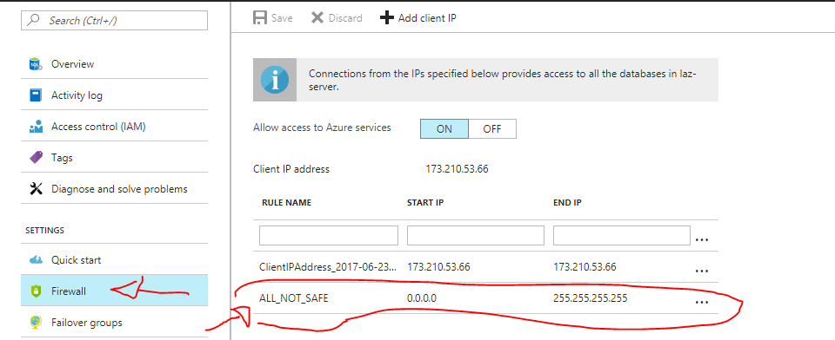

* Need to setup (I think) a SOCKS5 proxy to use static IP
  + SEE:
  + <https://devcenter.heroku.com/articles/quotaguardstatic#http-vs-socks5-proxy>
  + <https://devcenter.heroku.com/articles/quotaguardstatic#using-with-node-js>
  + <https://devcenter.heroku.com/articles/quotaguardstatic#socks-proxy-setup>
* Should perhaps reach out to get professions advice first
* Also read up on how proxies work, SOCKS5 tunnels, database stream. Etc.

**UPDATE: the SOCKS5 should now work iy”H. It was failing before because I forgot to do build before deploying !!!!!!!**

**B”H that was discovered.**